Abstract Title (Arial, bold, 14pt, centered)
Author1 N.I.,¹ Author2 N.I.,² (full list of authors, Arial, 12pt, centered, Presenting author underlined)
¹Name and address of the affiliation for Author1 (Arial, italic, 10pt, centered)
²Name and address of the affiliation for Author2
e-mail: abc@xyz.com (email address of the presenting author only)
Text of the abstract (in English), Arial plain 12 pt, justified. 1 page maximum. References should be formatted as superscirpts.^{1, 2} Images and schemes (optional) should be appended at the end of the text. Please do not place empty lines between paragraphs. Do not remove empty lines in this template. Please use suggested styles.² Please not exceed one page for whole abstract.
For current information about the symposium see http://volpin2023.ru
Text text text text text text text text text text text text text text text text text text text text text text text text text text text text text text text text text text text text text text text text text text text text text text text text text text text text text text text text text text text text text text text text text text text text text text text text.²
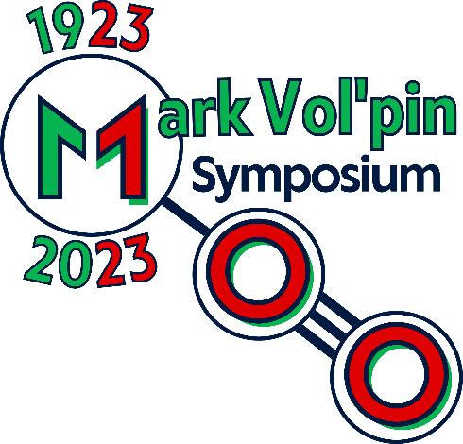
Figure 1. Caption. Please use graphics with reasonable resolution
Acknowledgements
Text of the acknowledgements (optional), Arial plain 10 pt
References
1. A. B. Author, C.D. Coauthor, Science 2018, 20, 1200.
2. A. B. Author, C.D. Coauthor, J. Boron Chem. 2013, 117, 8263.

